2QueueOOL4u

September 20, 2017

Project Proposal

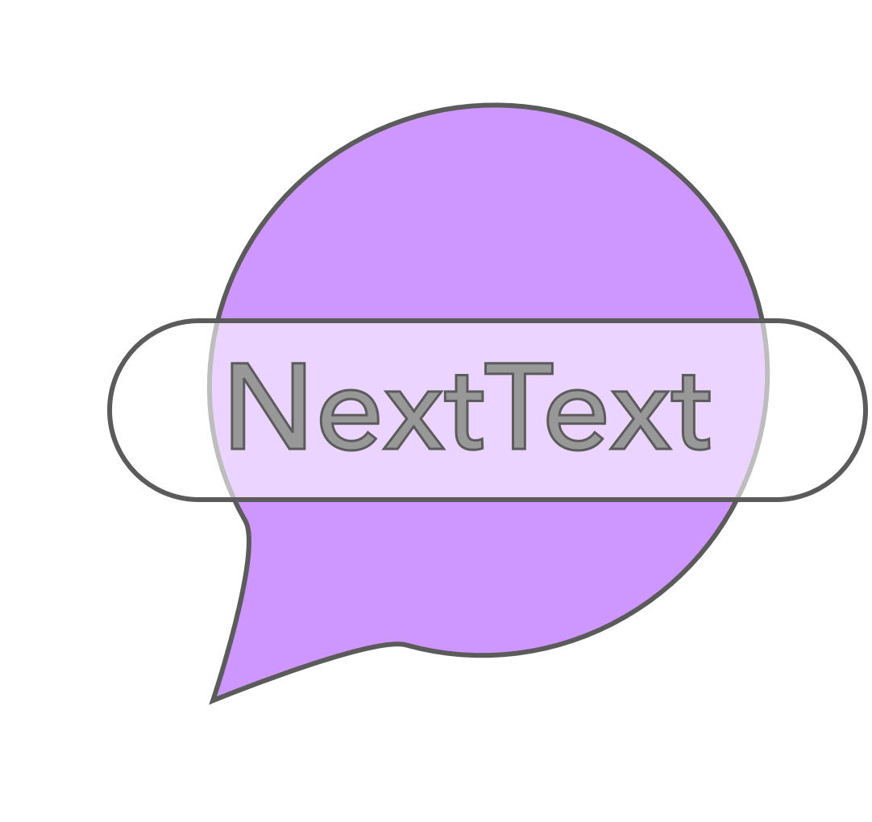

*What is our team name?*

2QueueOOL4U

*What is our project/app name?*

NextText

*Who are our team members and what are their IDs?*

James Mulvenna/100965629

Yue Zhang/100980408

Devon Plouffe/100715712

*What is our project?*

Did you know texting while driving makes an accident 23 times more likely? (ThinkInSure, 2017) Each basic text you make while driving will seize a minimum of 5 seconds of your attention (ThinkInSure, 2017), which should evidently be focused on the road itself. In addition, there are many more multitasking implications where your mobile device strips valued concentration due to lack of willpower. A separate example is a necessary conversation with a peer. Imagine your peer informs you COMP 3004 D1 is due 20/09/17, meanwhile you were preoccupied relaying a message to your mother that you will be home at 3 PM. Wednesday rolls around and you have forgotten to submit your deliverable, resulting in an F course grade. NextText, will leverage technology to perform this function on your behalf, constrained to your predilection. You can feel confident your message will be sent with regards to your preferences. Over the duration of Fall 2017, 2QueueOOL4U will develop a messaging utility called NextText. NextText will send automated text-based messages including forms such as SMS, E-mail, Facebook messenger and other common messaging schemes. Message dispatch will be confined to either time, location or weather. It is imperative to add that the sending action will require no user compliance. Instead, we will use the earlier approved confinement to send your message on your behalf. With the use of back-end server management and messaging clients, this is a feasible proposition.

*Why is it interesting?*

As the statistics prove, this is a necessary situation to be dealt with. Seeing that technology is expanding further, resolving everyday issues is becoming more attainable. If NextText was widely used, we would help reduce message thoughtless multitasking by a substantial measure. Clearly, texting while driving is a huge problem and while the Ontario law is subject to $490 fine plus 3 demerit points (Ontario, 2017), society neglects compliance. As a team, we desire to build an application to serve the better of the people. We credit technology for being useful in a convenient sense. As we analyzed the mobile market, we observed that this niche was undermined. Knowing this, we took interest in developing a unique, minimalistic and effective application to serve this function.

*Description/justification on our project selection:*

Our project selection is justified for its societal demand. As stated previously, texting while driving is a great example to illustrate the potential benefits of our application. Traditional solutions to texting while driving include:

* Pulling over
* It can wait

However, by utilizing NextText you will eliminate issues such as:

* Accidents
* Safety of others
* Breaking the law
* Insurance costs
* Occupied attention
* Extended trips

Yet, still get your message(s) across. NextText will easily accomplish your preset task on your behalf so you can carry out more important tasks.

*Why does this project make sense in a mobile form factor?*

Beginning with two relevant questions, do you ever turn off your phone? How about your laptop? While it is inappropriate to attend your phone during church or a family dinner, I can assure you it is probably still online and within reach. Research shows 90% of Americans carry their phone with them consistently. Text-based messages is becoming primarily a mobile action, as opposed to stationary actions. Whether you’re riding transportation, attending a lecture or socializing with friends your phone is most likely with you and as a team, it would be irrational not to believe you didn’t glance at your phone at some instant during the span of the three examples above. Furthermore, texting while driving is the most considerable controversy to manage which is clearly a mobile form.

*What are the functional properties of your system?*

1. The system should have the ability to save user information
2. The system should be able to import users contacts
3. The system should be able to access conditions
4. The system should list queued messages
5. The system should be able to add new queued messages
6. The system should be able to modify existing queued messages
7. The system should respect user privacy and authorization

*User scenario 1 (Basic):*

Consider a scenario in which you are going on a road trip to Toronto to see the biggest festival of the summer. You are attending this festival with four of your closest friends. You were supposed to leave yesterday, but something came up at work… you had to put in overtime. So, you ended up leaving early this morning. It was crucial you picked up friend 4 by 10 AM or else you would miss part of the festival. First, you opened up NextText on your iPhone. Considering you already entered in useful information like your first name, last name and phone number, you proceeded to tap the add button. After doing so, you chose the contact to be friend 4, constrained the text to send when you were within a 100-meter radius of his residence and finally entered your message: “I’ll be there in 1 minute! Please be ready friend 4 ☺”. You then added the entry to the queue. The benefit of this scenario to you is your message sent when you needed it to and you made it to the festival in a timely fashion.

*User scenario 2 (Advanced):*

Consider a scenario in which you are going meeting a friend after class to go over your project proposal, you plan on meeting them when the weather is sunny because you still want to enjoy the weather during your meeting. It just so happened there was overcast today, and you knew there wouldn’t be any existence of sun. Knowing this, after class you opened NextText and swiped left on your queued message to modify it so that it now stated, “Hey bob, I overlooked the weather for today and unfortunately we can’t meet in any sunny period. So instead, I’ll text you when I’m nearing the mall so we can get something to eat while we work.” You then change the condition to text Bob when you are within a 200-meter radius of the mall and tap add to queue. The benefit of this scenario to you is that you were able to assess the weather conditions and modify your message based on another condition without deleting the entry. Your message took the alternative direction and was able to send confidently so that you would still meet Bob over food at the mall in contrast to outside in the sun.

*What are the non-functional properties your system needs to support?*

1.1 User information will have the ability to be modified

2.1 Native contacts, Facebook contacts and E-mails contacts will be able to be imported

3.1 Time based services will be used, location based services (API) will be used, weather information (API) will be relayed incrementally

4.1 A list of stored messages will be visual and accessible to the user

5.1 User will have the ability to choose their contact and condition in an “add” interface

7.1 The application will respect the permissions the user has set

*Why are they important?*

These requirements are important to create a vital cycle for the user. In other words, with these requirements the application is unbreakable with regards to modifications, additions, deletions and other operations. They will have the ability to use the functionality of the utility to the full extent within the projected behavior of the application.

*Mock ups:*

Setting screen;

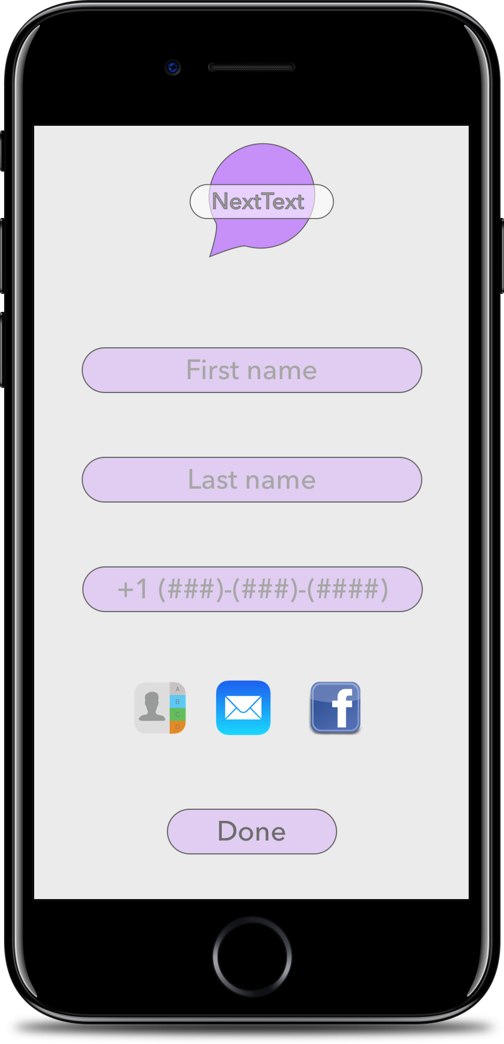

Main screen;

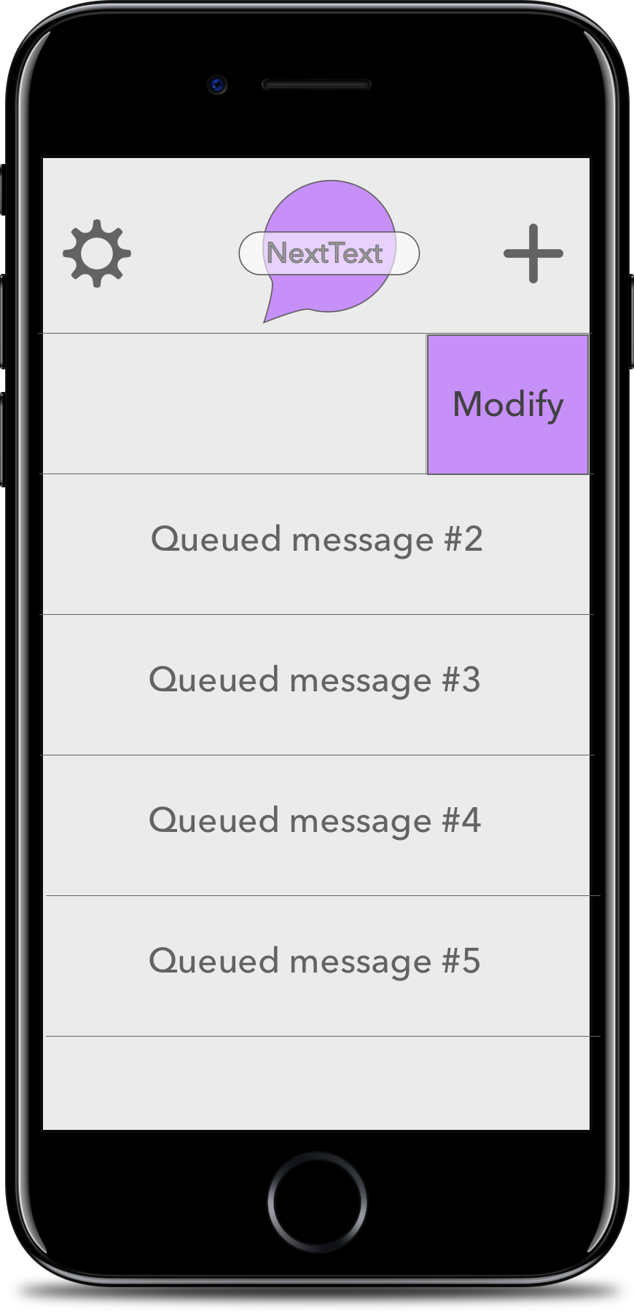

References:

Ltd., T. (2017, February 23). Texting And Driving In Ontario – Keep Your Hands Off Your Phone And Eyes On The Road. Retrieved September 21, 2017, from <https://www.thinkinsure.ca/insurance-help-centre/texting-and-driving.html>

(n.d.). Retrieved September 21, 2017, from <https://www.ontario.ca/page/distracted-driving>